Saturday 9 March 2024
New Plymouth Yacht Club, Oceanview Parade, Ngāmotu Beach, New Plymouth
Panui 2
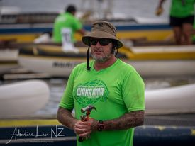
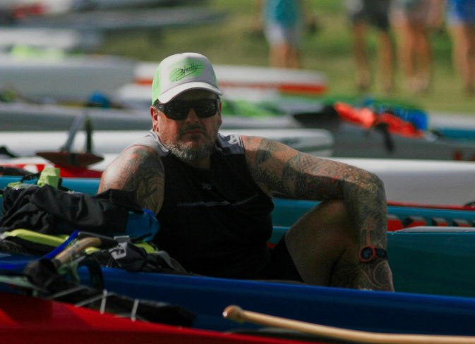
Dan Fraser

In this race we remember our mate, Dan Fraser, a true legend in the surfing and waka ama community, who left us too soon on July 2nd, 2023. Dan embodied the very essence of our club – Culture, Competition, Lifestyle, and Heart.
Dan was one of the "good ones", a character, next level hard core on the water and off. He pushed limits and encouraged us to go hard, always ready to help and have a shared laugh. He was more than a fellow paddler; he was an integral part of our club whānau. His sudden passing leaves an empty space that cannot be filled.
Last year, we achieved a milestone with our first race, and Dan was at the core of that success. From the early planning stages to sorting out the racecourse, keeping an eye on the conditions, and ensuring everyone stayed safe, Dan was there every step of the way.
His legacy is woven into the fabric of our club and this race. Farewell, e hoa, your paddle strokes may be silent, but the ripples of your impact will forever be felt in Ngā Tai e Whā o Taranaki.

Event Summary

This event showcases the best of Taranaki conditions. This event will be based at the New Plymouth Yacht club situated at the western end of Ngāmotu Beach. Registration and administration will be inside the yacht club.

Race Details

Race1: W6 Short Course | 8 -11km | Short | Women / Men / Mixed
Race2: W6 Long Course | 19 -22km | Experienced | Women / Men / Mixed

Information on the event can be found on the Waka Ama NZ website -Ngā Tai e Whā o Taranaki Dan Fraser Memorial 2024

IMPORTANT REGISTRATION INSTRUCTIONS

Please register your intent to race online with Waka Ama NZ

AND

email the registration and event waiver form to Rosie, Club Secretary at info.taranakiocc@gmail.com.

All participants (teams and individual) must complete an event waiver. The event waiver is included as part of the Registration and Event Waiver Form and can be found online here:
Ngā Tai e Whā o Taranaki Dan Fraser Memorial 2024 Registration and Event Waiver form

Early completion and submission will speed things up on race day.

Waka Hireage
For any queries on waka hireage, please contact Rosie, Club Secretary, 027 7567174, info.taranakiocc@gmail.com

Race Fee:

$25.00 per person for 1 Race $35.00 for 2 Races

Payments
Please pay by direct credit to:
Taranaki Outrigger Canoe Club
15 3953 0774834 003

Please put the following details to identify your payment:

Payment Identifiers | Required info | Example
Particulars - | Club Name | Taranaki OCC
Code - | Race & Waka Hire | Short & Waka
Reference - | Team Name | Wairere

Refund Policy
- No refunds will be given for any withdrawals after 3 March 2023
- No refund will be given if the event is cancelled due to a natural disaster or extreme weather

Race Day Schedule

0700 | Opening karakia
0720 | Registration desk open  Waka safety checks for Race 1
0830 | Race 1 briefing
0900 | First race start
0900 | Waka checks for race 2 available
1030 | Race 2 race briefing.
1100 | Race 2 start

Kai will be available once all Race 2 competitors safely return.
Prize giving shortly after kai.

Race Day Safety Information

High Tide -9.51am, 3.6m

Expected weather is overcast and 21°C

Be prepared to race with skirts if conditions require them.

Full PFD is required – no horseshoe or belt lifejackets will be accepted.

Competitors Ability
We are providing opportunities for experienced and capable crews aged 19 and above. The term “experienced” means that teams and individuals have experience in OPEN SEA conditions.
All Clubs are responsible for ensuring that all paddlers are fit and competent in the race that they have been entered into.

The Race Director has the discretion to withdraw a team or an individual who is deemed to be unfit or unprepared to complete the race.

Venue: Ngāmotu Beach

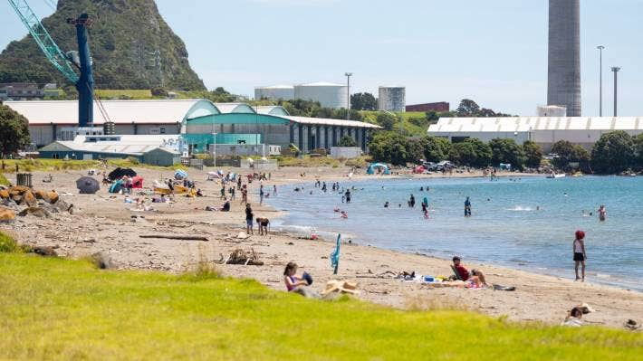

Ngāmotu Beach has great facilities for a whanau day out. Great playground for the kids, large grassed, area for picnic/gazebos etc. Safe Swimming Beach.

Kai: Hot kai for all paddlers is included in the race fee and will be provided inside the Yacht Club after the race.
Supporters and spectators are welcome to purchase kai from local cafes/restaurants.

Toilets: Toilets are available inside the Yacht Club and also at the Playground at Ngāmotu Beach.
First Aid: First Aid will be available at the registration, via main driveway.
Rubbish/Recycling: We encourage you to please take what you bring. However, the main rubbish and recycling station is located by the childrens playground.
Alcohol/Smokefree: Alcohol, smoking, vaping and any other substance use is not permitted at this event, including all premises of the event.
Please respect our Beaches and be a tidy kiwi.

Venue Map

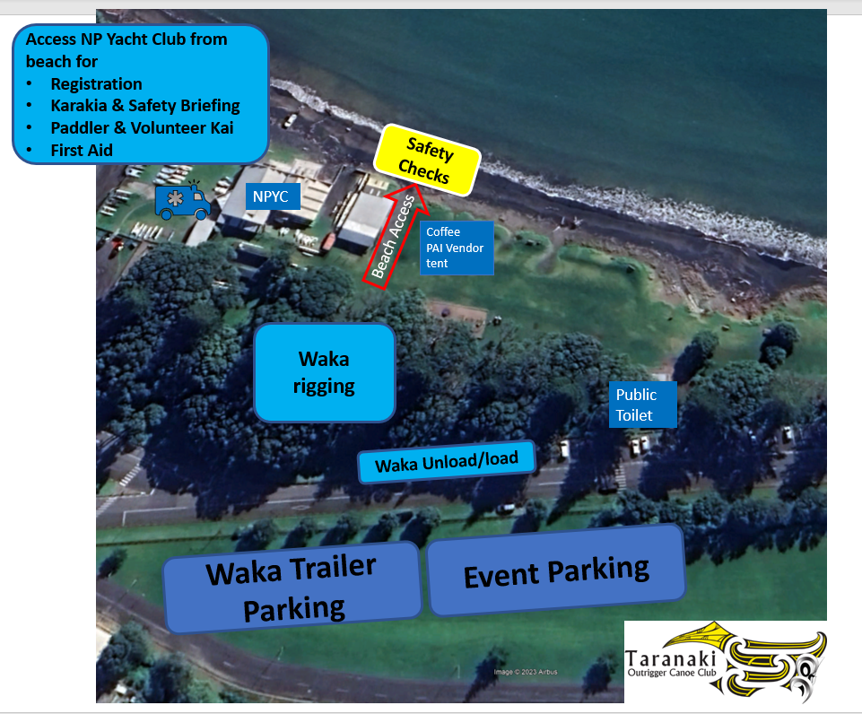

Parking of Waka & Trailers in designated area on Ocean View Parade Moturoa

Local Accommodation Options:
There are many local accommodation options including:
Belt Road Seaside Holiday Park – 1km from Ngamotu
Fitzroy Beach Holiday Park – 6km away
Oakura Beach Camp - 15km away
The Dawson Motel -7km away
Bella Vista Accomodation 7km away

Merchandise

Event t-shirts in Men’s and Women’s sizes will be available to buy on the day.

Key Contacts

To arrange access for parking and waka offloading the night before the event, please contact Karen Bergman, 027 2413881

Any other queries:
Club Secretary: Rosie Johnson, 027 7567174, info.taranakiocc@gmail.com
Event Manager: Nikyla Fraser 021 375 537
Event Co-ordinator: Karen Bergman Sutton 027 241 3881

